Bug Report Template

Bug ID:
[Read] – [1]
Title:
Korean Version Unavailable
Environment:
Browser: All Browser
OS: Windows
Device: Desktop
Build/Version: 1.0
Preconditions:
1. None
Steps to Reproduce:
1. Navigate to /Study
2. Click and open the version module
3. Select KOR- Korean
Expected Result:
Bible
Actual Result:
Error message displayed
Severity:
Critical
Priority:
High
Status:
Open
Attachments:
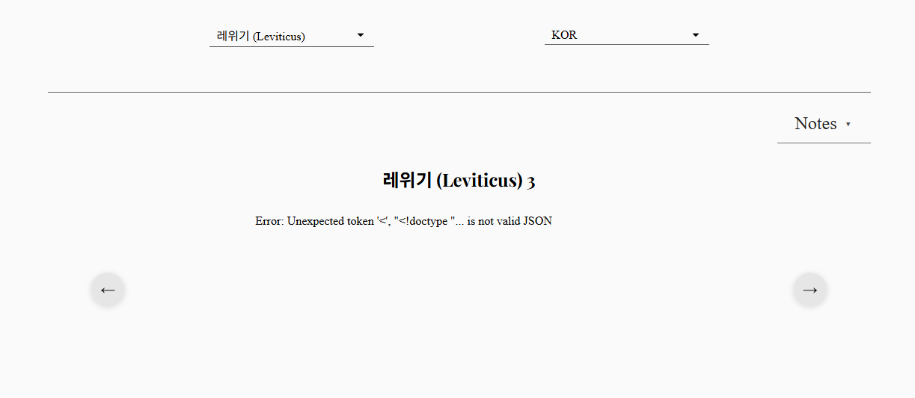Notes / Root Cause (Optional):
Korean API handling failed. Needs investigation

